ALTERNATIVE CONFIGURATION FOR EJC QUOTING

KWIK QUOTE

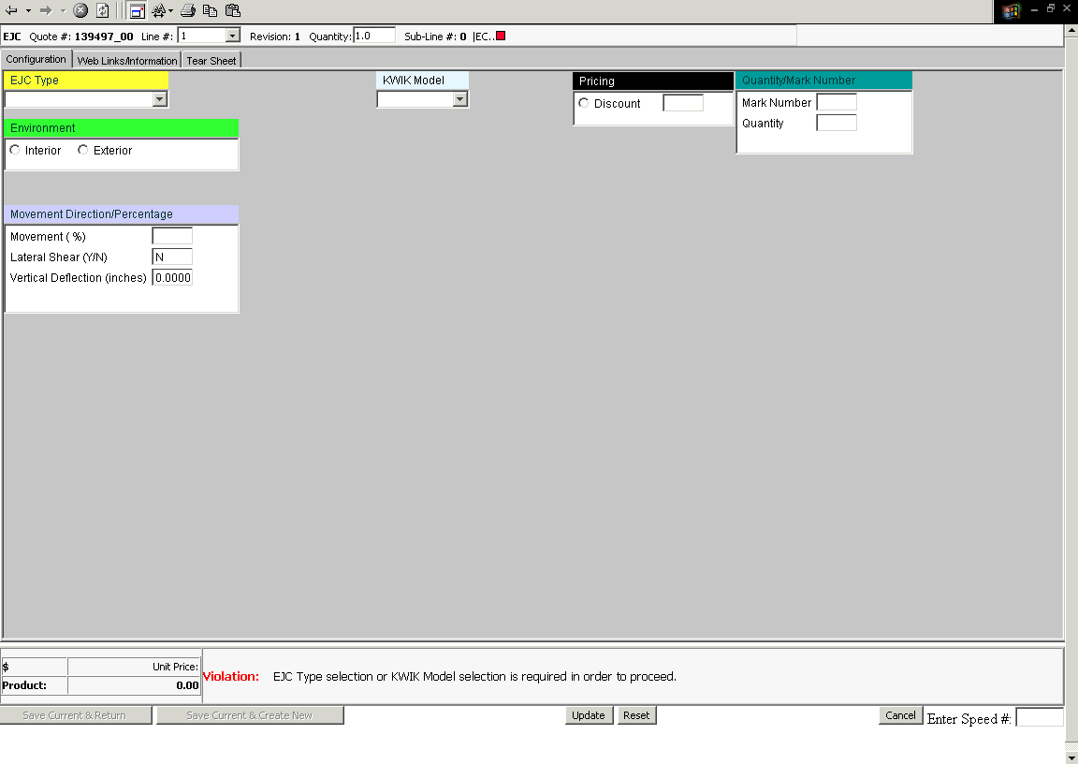

When entering into the configurator you will see the familiar screen as shown.

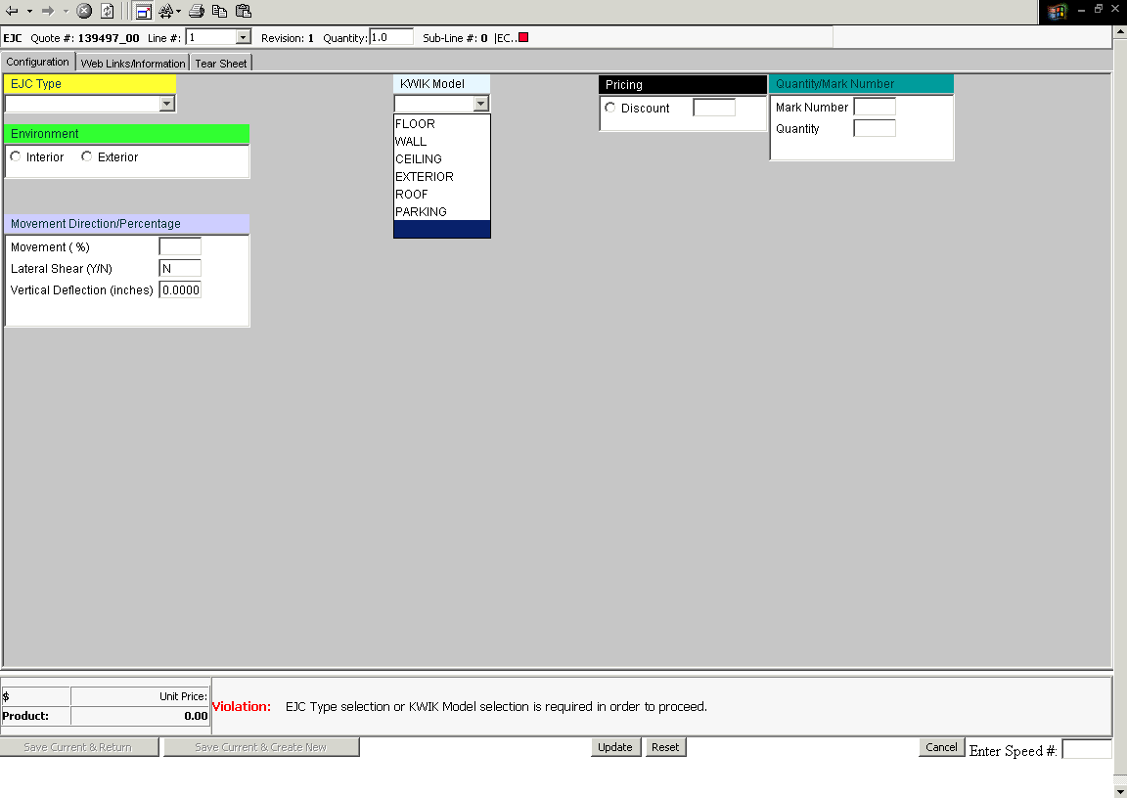

- The first step is to pick a Kwik Model from the drop down menu.
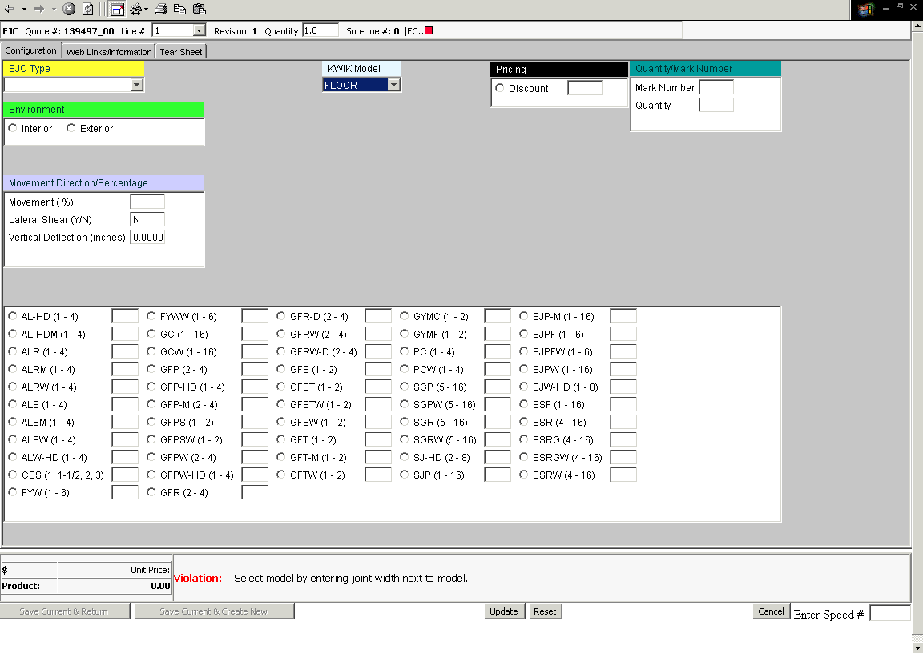

- Once selected, all model prefixes associated with the Kwik Model type populate the screen.

- Notice that the available joint widths are in parenthesis behind the model number. If it shows (1-4), then it is available for 1”, 2”, 3”, or 4” joint widths.

- Some models will list specific joint widths, such as WF, due to the odd sizes available.
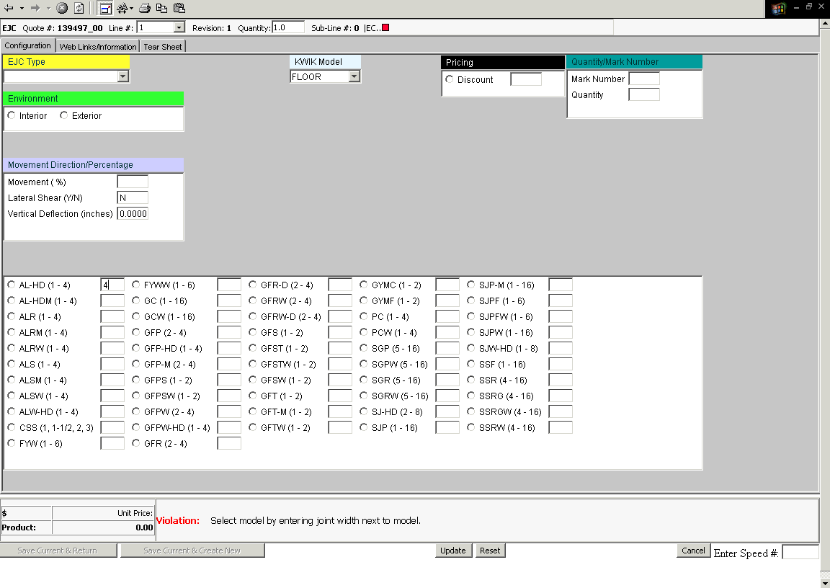
- On this screen simply click in the box behind the desired model, and enter the joint width.
- NOTE: You do not have to select the product before entering the joint width, and in fact may have errors if you do.

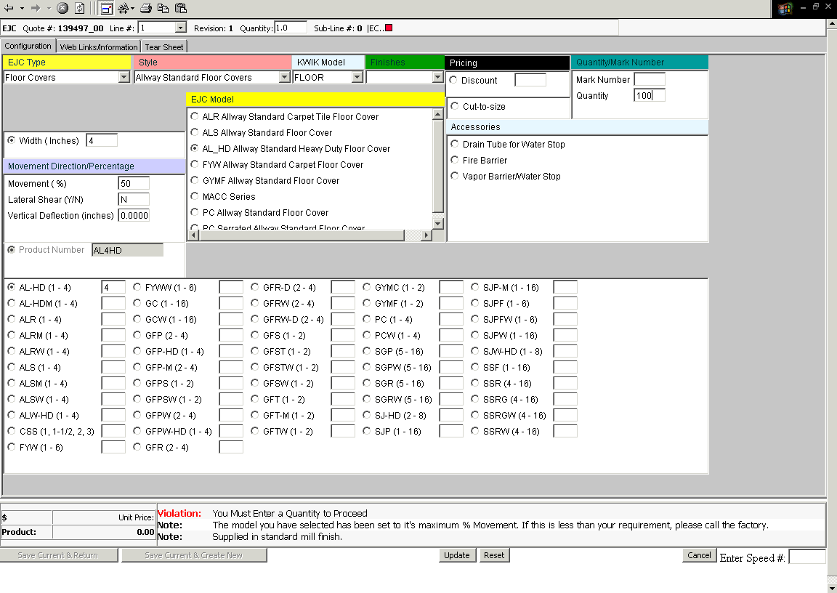

- From there, you will need to add the quantity, which can be done on the same screen.
- Hit the Update button after you enter the quantity and mark number (mark number not required for pricing).
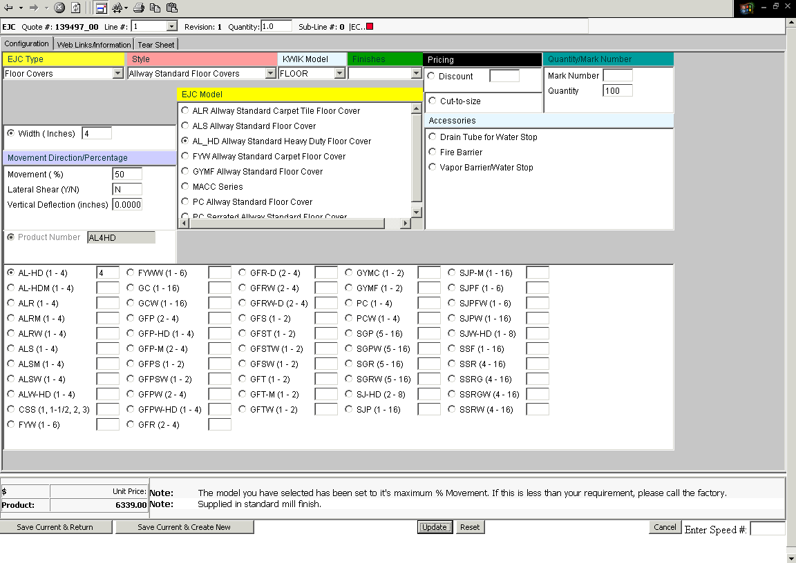

- Notice that the Configuration tab is populated with all of the pertinent information you just entered.
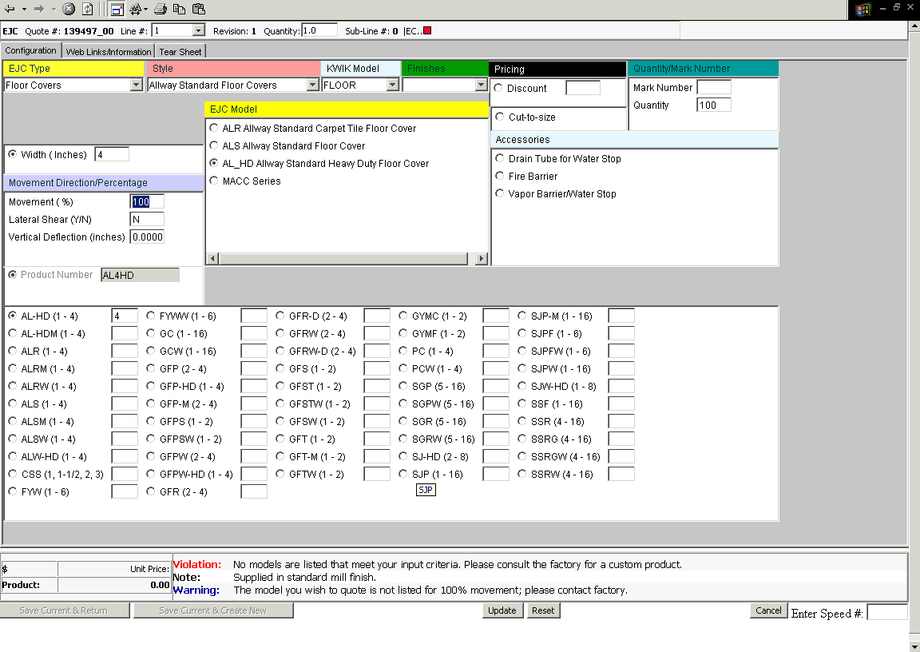
- You can check for alternative movements (standard movement is defaulted – 50% for flat conditions and 25% for corner conditions). 100% is typed in here to see if it was available – the violation tells me it is not.
- You can change joint width.
- You can change model type on this screen.
- You can change quantity on this screen.
- You can change the mark number on this screen.
- You can add your finishes on this screen.
- NOTE: Some models selected will require additional information to be entered on this screen, such as depth for the GFT models.
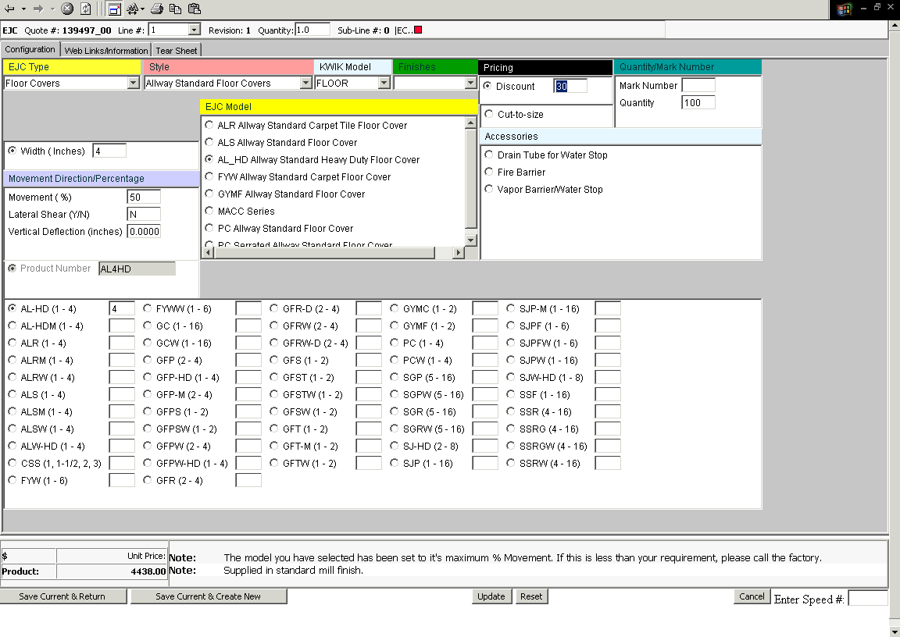

- If you want to discount your quotation, it is best to do it on the first line item, so that it carries through for your accessories.
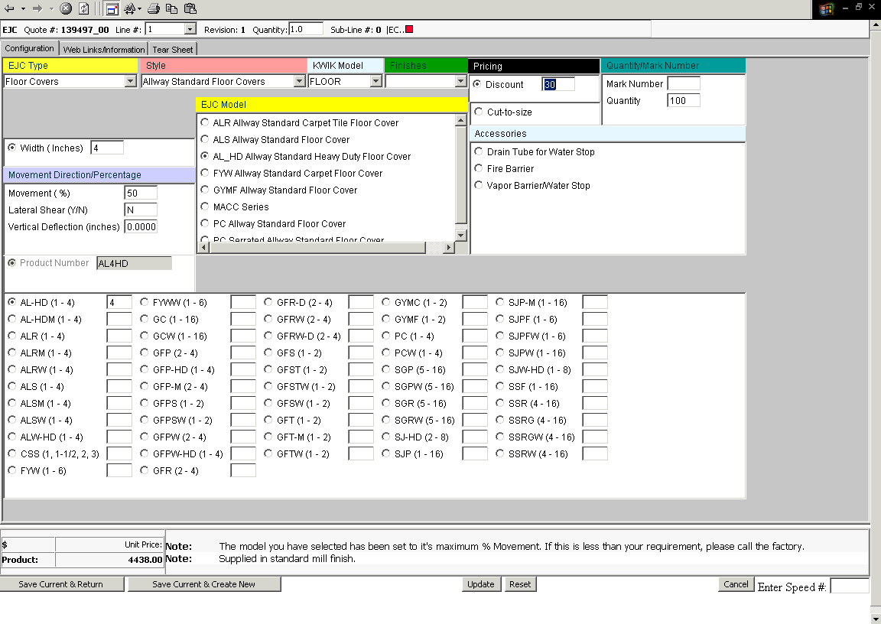

- Use the Save Current and Create New to add accessories, or hit the Save Current and Return button if you are finished.
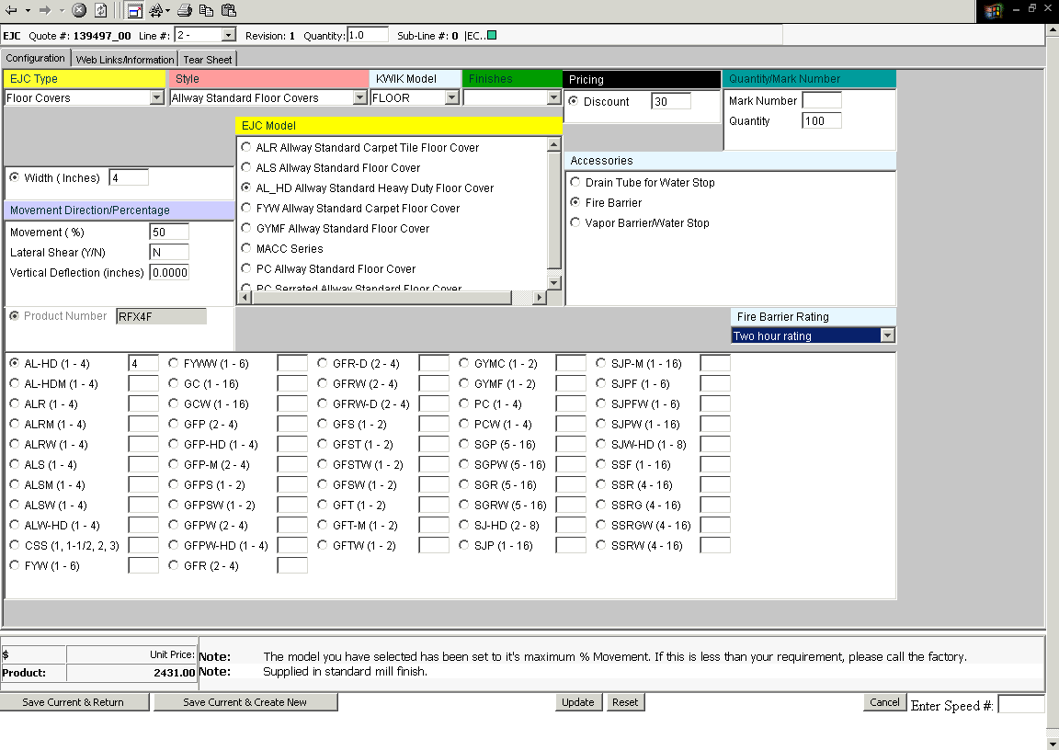

- Once saved, you can add your accessories. In this instance 2-hour fire barrier was added. Note that this must be done after saving your cover profile.

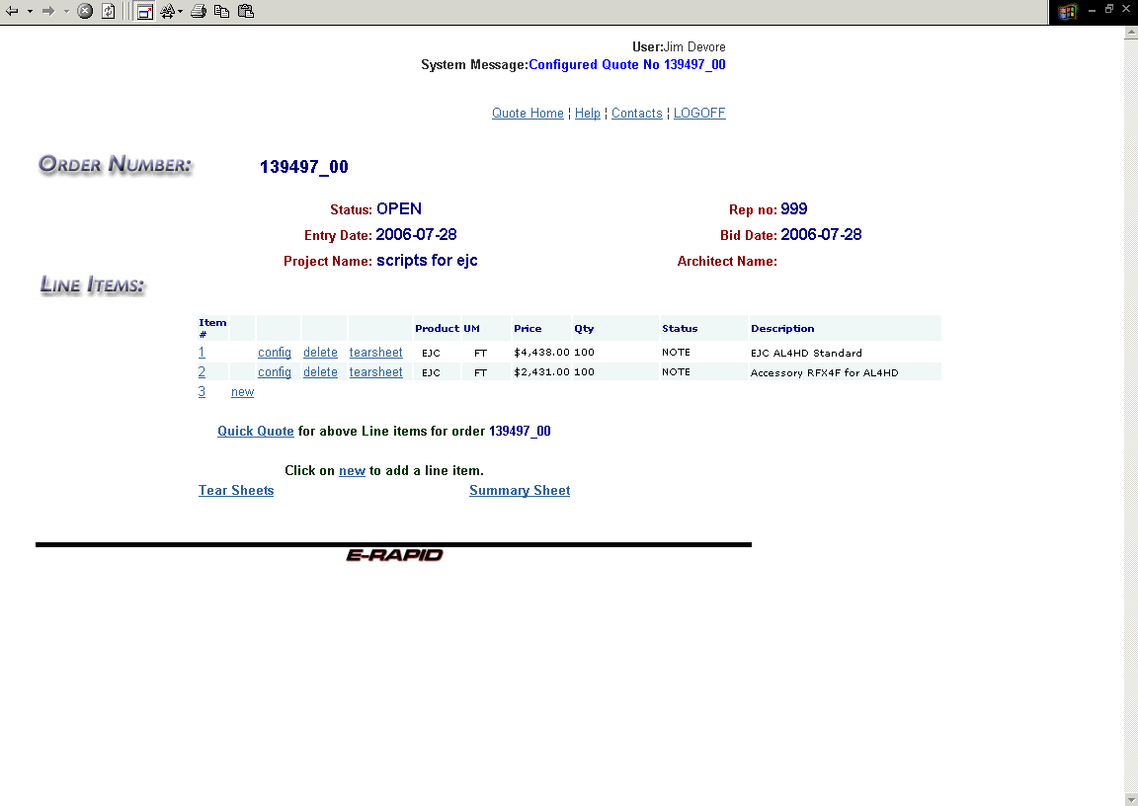

- Hit the Save Current & Return button when everything is done, and you are back to the line item screen.

